PYTHON PROGRAMMING – CSA0805
K. Shalini (192512270)

Q1 – LISTS AND SLICING: DAILY RAINFALL RECORDS (6 MARKS)
1. Aim
To develop a Python program using lists and slicing to analyse daily rainfall records, calculate weekly totals, find maximum and minimum rainfall, calculate moving averages and identify dry days.
2. Problem Statement
A village rain-gauge station records rainfall in millimetres every day for one year. The readings are stored in a list of 365 values. The program analyses these readings to calculate weekly totals, identify the wettest and driest days, calculate a 7-day moving average and find days with zero rainfall.
3. Python Program
import random
random.seed(10)
# Generate 365 rainfall readings
readings = [random.randint(0, 100) for i in range(365)]
# Calculate weekly totals
weekly_totals = []
for i in range(0, 365, 7):
weekly_totals.append(sum(readings[i:i+7]))
# Find maximum and minimum rainfall
maximum = max(readings)
minimum = min(readings)
max_day = readings.index(maximum) + 1
min_day = readings.index(minimum) + 1
# Calculate 7-day moving average
moving_average = []
for i in range(len(readings) - 6):
average = sum(readings[i:i+7]) / 7
moving_average.append(average)
# Find dry days
dry_days = []
for i in range(len(readings)):
if readings[i] == 0:
dry_days.append(i + 1)
print("Total readings:", len(readings))
print("Weekly totals:", weekly_totals)
print("Maximum rainfall:", maximum)
print("Maximum rainfall day:", max_day)
print("Minimum rainfall:", minimum)
print("Minimum rainfall day:", min_day)
print("Moving averages:", len(moving_average))
print("Dry days:", dry_days)
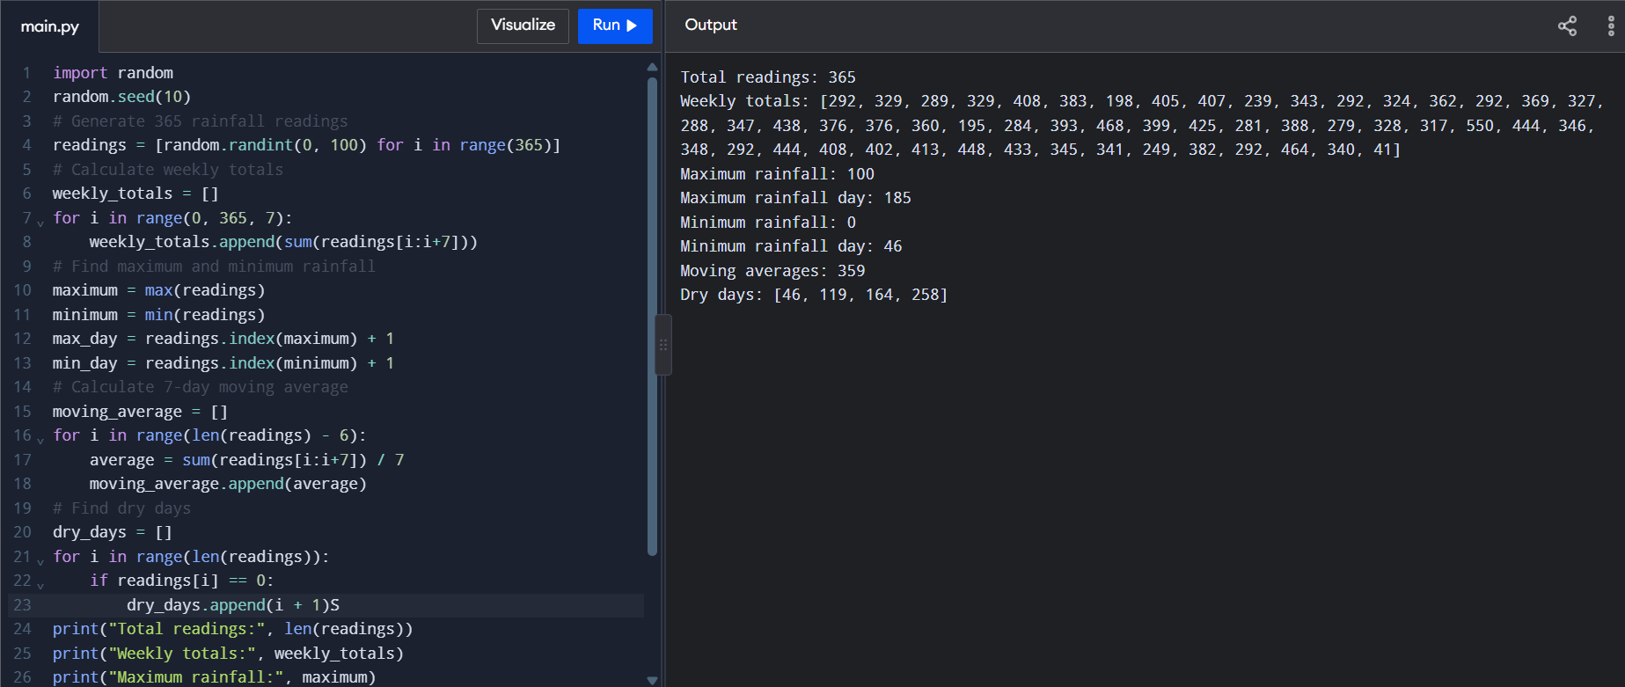
4. Input and Output
Input: The program generates 365 rainfall readings using the random module.
Output: The program displays weekly rainfall totals, maximum and minimum rainfall with their day positions, the number of moving averages and the list of dry days.
5. Analysis of Data
The rainfall readings are stored in a list because lists maintain order and allow easy access, insertion and deletion of values.
List slicing:
- readings[7:14] – Returns readings from index 7 to index 13.
- readings[-7:] – Returns the last seven readings.
- readings[::7] – Returns every seventh reading starting from the first reading.
List operations and their costs:
Operation | Time Complexity
append() | O(1) amortized
insert() | O(n)
pop() at the end | O(1)
sort() | O(n log n)
6. Pseudocode for Moving Average
- Start.
- Store rainfall readings in a list.
- Select seven consecutive readings.
- Calculate their sum.
- Divide the sum by 7.
- Store the average.
- Move to the next day.
- Repeat until all possible seven-day windows are completed.
- Stop.
7. Time and Space Complexity
For n rainfall readings:
Operation | Time Complexity
Weekly totals | O(n)
Maximum and minimum | O(n)
Dry-day identification | O(n)
Naive moving average | O(7n) = O(n)
Running-sum moving average | O(n)
The rainfall list requires O(n) space. The moving-average result also requires O(n) space.
Number of additions:
- Naive method: Each seven-day window needs 6 additions. Total = 6 × (n - 6).
- Running-sum method: The first window needs 6 additions. Each next window needs only one new addition and one subtraction.
Therefore, the running-sum method avoids repeated calculations.
8. Experimental Investigation
The following program compares the execution time of the naive and running-sum methods for different dataset sizes.
import random
import time
def naive(data):
result = []
for i in range(len(data) - 6):
result.append(sum(data[i:i+7]) / 7)
return result
def running(data):
result = []
if len(data) < 7:
return result
total = sum(data[:7])
result.append(total / 7)
for i in range(7, len(data)):
total = total + data[i] - data[i-7]
result.append(total / 7)
return result
for n in [365, 36500, 365000]:
data = [random.randint(0, 100) for i in range(n)]
start = time.time()
naive(data)
print("Naive time:", time.time() - start)
start = time.time()
running(data)
print("Running sum time:", time.time() - start)
print()
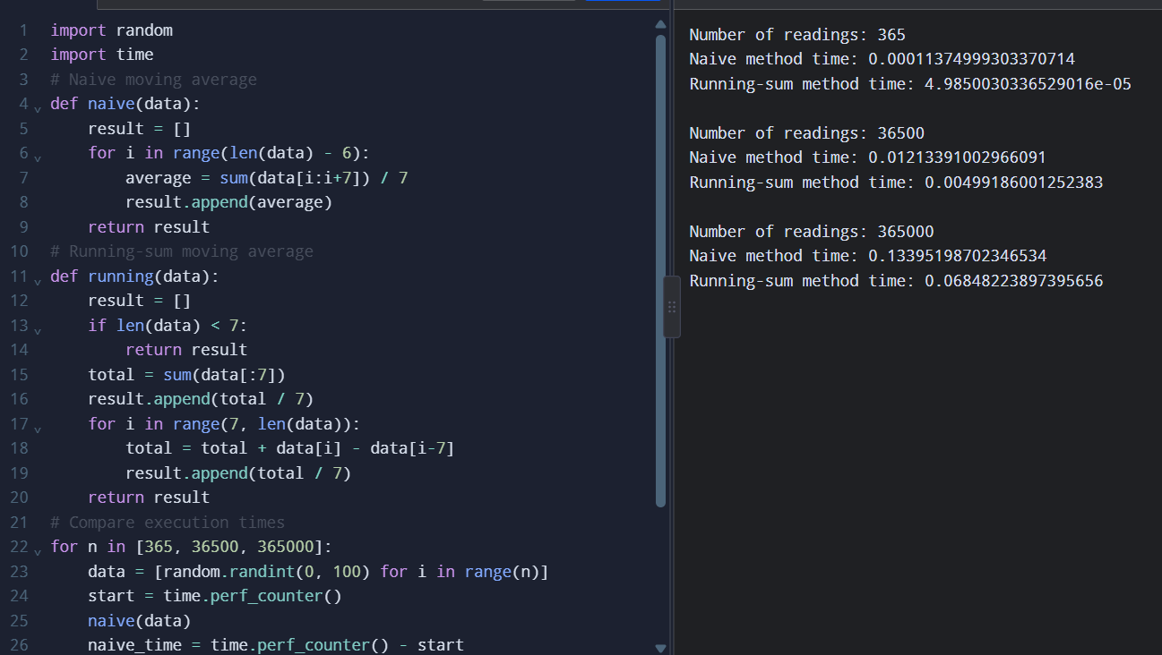
The program measures the execution time for 365, 36,500 and 365,000 readings. The running-sum method is generally faster because it avoids repeated additions.
Additional tests:
- Empty list: No moving averages are produced.
- List with fewer than seven readings: No moving averages are produced.
9. Design Question and Alternative Concept
If a rainfall reading arrives late, list.insert() can insert it at the correct position. Its time complexity is O(n) because elements may need to be shifted.
An alternative is to use collections.deque(maxlen=7) to maintain a seven-day moving window. With a running sum, the moving average can be calculated in O(n) time. A dictionary keyed by date is another option when readings need to be accessed using specific dates.
10. Conclusion
The program demonstrates how Python lists and slicing can be used to analyse daily rainfall records. It calculates weekly totals, identifies maximum and minimum rainfall, finds dry days and calculates moving averages. The running-sum method improves efficiency by reducing repeated calculations.

Q2 – TUPLES, MUTABILITY AND COPYING (7 MARKS)
1. Aim
To understand Python tuples, mutability, aliasing, shallow copying and deep copying using a bus-stop map and passenger-counting grid.
2. Problem Statement
A city bus service stores the GPS coordinates of bus stops as latitude and longitude pairs. It also uses a grid to count passengers boarding in different zones.
When the grid is created using [[0] * cols] * rows, all rows refer to the same list. Therefore, changing one row also changes the other rows. This problem can be corrected using list comprehension.
3. Python Program
import copy
# Create an incorrect grid
rows, cols = 3, 4
bad = [[0] * cols] * rows
bad[0][1] = 7
# Create a correct grid using list comprehension
good = [[0 for j in range(cols)] for i in range(rows)]
good[0][1] = 7
print("Bad grid:", bad)
print("Good grid:", good)
# Check memory references
print("Bad rows same:", bad[0] is bad[1])
print("Good rows same:", good[0] is good[1])
# Represent bus stops using tuples
stops = {
(13.0827, 80.2707): "Chennai Central",
(13.0418, 80.2337): "Guindy"
}
print("Bus Stops:")
for (latitude, longitude), name in stops.items():
print(name, latitude, longitude)
# Demonstrate aliasing
original = [10, 20, 30]
alias = original
alias[0] = 100
print("Original:", original)
print("Alias:", alias)
# Demonstrate shallow copy
shallow = copy.copy(original)
shallow[1] = 200
print("Original after shallow copy:", original)
print("Shallow copy:", shallow)
# Demonstrate deep copy
nested = [[1, 2], [3, 4]]
deep = copy.deepcopy(nested)
deep[0][0] = 99
print("Original nested list:", nested)
print("Deep copy:", deep)
# List stored inside a tuple
data = ([1, 2, 3], "Bus")
data[0].append(4)
print("Tuple containing list:", data)
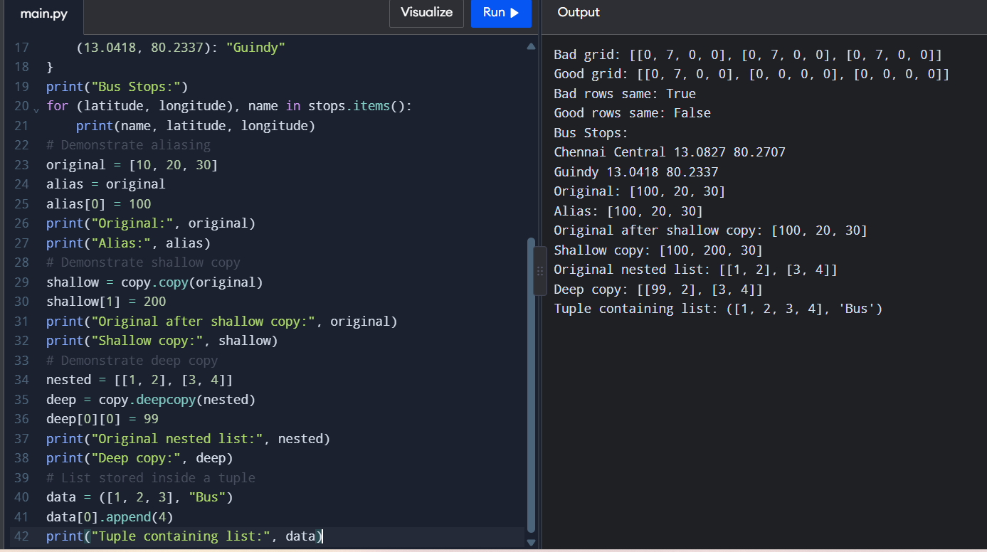
4. Input and Output
Input: The program uses predefined GPS coordinates and passenger-counting grids.
Expected Output:
Bad grid: [[0, 7, 0, 0], [0, 7, 0, 0], [0, 7, 0, 0]]
Good grid: [[0, 7, 0, 0], [0, 0, 0, 0], [0, 0, 0, 0]]
Bad rows same: True
Good rows same: False
Bus Stops:
Chennai Central 13.0827 80.2707
Guindy 13.0418 80.2337
Original: [100, 20, 30]
Alias: [100, 20, 30]
Original after shallow copy: [100, 20, 30]
Shallow copy: [100, 200, 30]
Original nested list: [[1, 2], [3, 4]]
Deep copy: [[99, 2], [3, 4]]
Tuple containing list: ([1, 2, 3, 4], 'Bus')
5. Analysis of Data
- Tuple: An ordered and immutable collection of values. Tuples can be used as dictionary keys when their elements are hashable.
- List: A mutable collection. Lists cannot be dictionary keys because they are mutable and unhashable.
- Aliasing: Two variables refer to the same object. Changes through one variable affect the other.
- Shallow copy: Creates a new outer object but shares nested objects.
- Deep copy: Creates a separate copy of the outer object and its nested objects.
Memory Diagram
Incorrect grid:
All three rows point to the same list.
bad
|
+---- Row 1 ----+
+---- Row 2 ----+----> [0, 0, 0, 0]
+---- Row 3 ----+
Correct grid:
Each row has a separate list.
good
|
+---- Row 1 ----> [0, 0, 0, 0]
|
+---- Row 2 ----> [0, 0, 0, 0]
|
+---- Row 3 ----> [0, 0, 0, 0]
A shallow copy is enough for a list containing immutable values. A deep copy is required when independent copies of nested mutable objects are needed.
When a function changes a list argument, the caller's list also changes because both refer to the same list object.
6. Time and Space Complexity
Operation | Time Complexity
Tuple indexing | O(1)
List indexing | O(1)
Dictionary access (average) | O(1)
Shallow copy | O(n)
Deep copy | O(n) for ordinary nested structures
Lists and tuples both require O(n) space for n elements. A deep copy requires additional memory for copied nested objects.
7. Experimental Investigation
The following program compares the memory usage and creation and indexing times of lists and tuples containing 1,000,000 values.
import time
n = 1000000
# Create list
start = time.perf_counter()
my_list = list(range(n))
list_time = time.perf_counter() - start
# Create tuple
start = time.perf_counter()
my_tuple = tuple(range(n))
tuple_time = time.perf_counter() - start
# Compare memory
print("List memory:", my_list.__sizeof__())
print("Tuple memory:", my_tuple.__sizeof__())
# Compare list indexing time
start = time.perf_counter()
for i in range(100000):
x = my_list[i]
list_index_time = time.perf_counter() - start
# Compare tuple indexing time
start = time.perf_counter()
for i in range(100000):
x = my_tuple[i]
tuple_index_time = time.perf_counter() - start
# Display results
print("List creation time:", list_time)
print("Tuple creation time:", tuple_time)
print("List indexing time:", list_index_time)
print("Tuple indexing time:", tuple_index_time)
# Check identity
print("List and tuple are different:", my_list is not my_tuple).
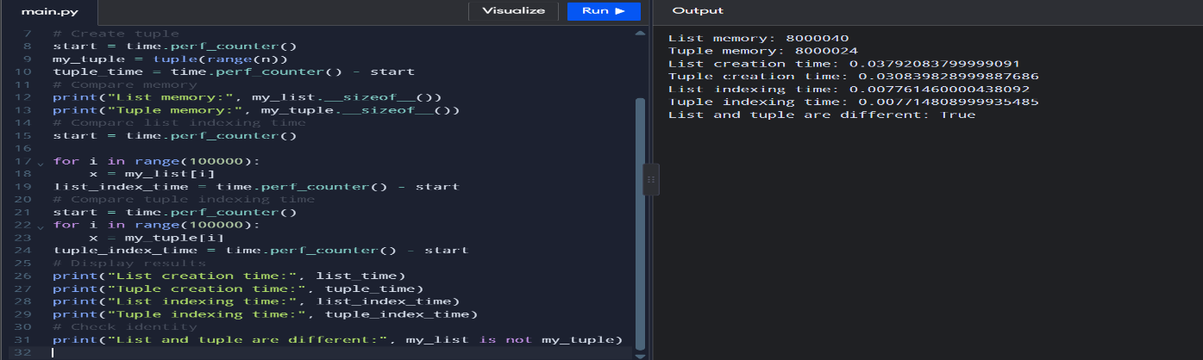
8. Conclusion
The program demonstrates the use of tuples for storing fixed GPS coordinates and lists for storing changeable passenger counts. It also explains aliasing, shallow copying and deep copying. Using list comprehension creates independent rows and prevents unwanted changes in the grid.

Q3 – DICTIONARIES: FARMER HELPLINE COMPLAINT ANALYSIS (7 MARKS)
1. Aim
To develop a Python program using dictionaries to analyse farmer complaints, count frequently used words, group complaints by district and identify the most common words.
2. Problem Statement
The Kisan call centre receives complaints from farmers about seeds, fertilisers and other agricultural problems. The agriculture department needs to identify frequently used words, count complaints from each district and group complaints according to crops.
3. Python Program
import string
# Farmer complaints
complaints = [
{"district": "Chennai", "crop": "Rice",
"text": "Seeds not received seeds delayed"},
{"district": "Madurai", "crop": "Wheat",
"text": "Fertiliser price high"},
{"district": "Chennai", "crop": "Rice",
"text": "Seeds price high subsidy not received"},
{"district": "Salem", "crop": "Cotton",
"text": "Cotton seeds not available"}
]
STOP = {"not", "high", "the", "is"}
# Count word frequencies using dictionary
def frequencies(texts, stop):
counts = {}
for complaint in texts:
words = complaint["text"].lower().translate(
str.maketrans("", "", string.punctuation)
).split()
for word in words:
if word not in stop:
counts[word] = counts.get(word, 0) + 1
return counts
# Group complaints by district
district_groups = {}
for complaint in complaints:
district = complaint["district"]
district_groups.setdefault(district, []).append(complaint["text"])
# Group complaints by crop
crop_groups = {}
for complaint in complaints:
crop = complaint["crop"]
crop_groups.setdefault(crop, []).append(complaint["text"])
# Find top k frequent words
def top(counts, k):
return sorted(counts.items(), key=lambda x: (-x[1], x[0]))[:k]
# Display results
word_counts = frequencies(complaints, STOP)
print("Word frequencies:", word_counts)
print("Top words:", top(word_counts, 3))
print("District complaints:", district_groups)
print("Crop complaints:", crop_groups)
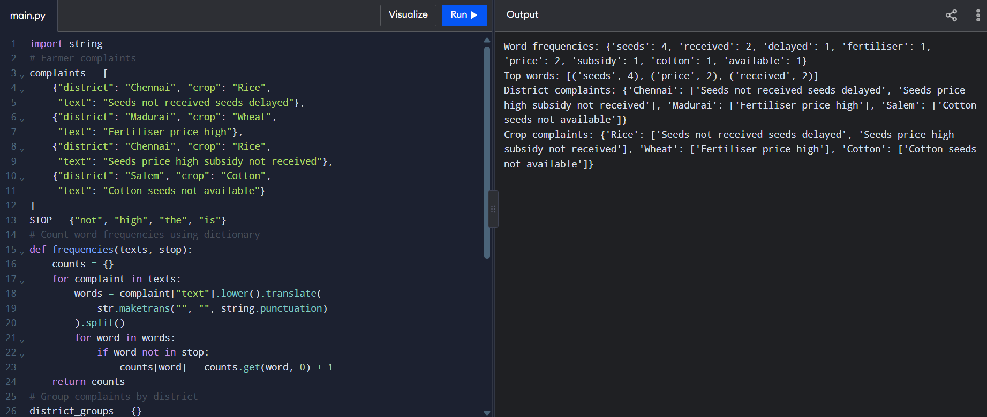
4. Input and Output
Input: The program uses predefined farmer complaints containing district names, crop names and complaint descriptions.
Output: The program displays word frequencies, the three most frequent words, complaints grouped by district and complaints grouped by crop.
5. Analysis of Data
A dictionary stores data in key-value pairs.
- get() retrieves a value and provides a default value if the key is not present.
- setdefault() creates a key with a default value if it does not exist.
- keys() returns all dictionary keys.
- values() returns all dictionary values.
- items() returns key-value pairs.
Python dictionaries maintain insertion order from Python 3.7 onwards.
Dictionary lookup takes O(1) time on average because it uses hashing to locate keys.
Counting words using a dictionary is more efficient than repeatedly using list.count() for every distinct word.
6. Time and Space Complexity
Method | Time Complexity
Dictionary word counting | O(n) average
Dictionary lookup | O(1) average
list.count() for each distinct word | O(n × d)
Sorting word frequencies | O(d log d)
Here, n represents the total number of words and d represents the number of distinct words.
The dictionary requires O(d) space for storing word frequencies.
7. Experimental Investigation
The following program compares dictionary counting, list.count() and collections.Counter for different complaint sizes.
import random
import time
from collections import Counter
words = ["seeds", "fertiliser", "price",
"subsidy", "water", "crop"]
for n in [1000, 10000, 100000]:
data = [random.choice(words) for i in range(n)]
# Dictionary method
start = time.perf_counter()
counts = {}
for word in data:
counts[word] = counts.get(word, 0) + 1
dict_time = time.perf_counter() - start
# list.count() method
start = time.perf_counter()
unique_words = set(data)
list_counts = {}
for word in unique_words:
list_counts[word] = data.count(word)
list_time = time.perf_counter() - start
# Counter method
start = time.perf_counter()
counter_counts = Counter(data)
counter_time = time.perf_counter() - start
print("Complaints:", n)
print("Dictionary time:", dict_time)
print("List count time:", list_time)
print("Counter time:", counter_time)
print()
The dictionary method and Counter generally perform faster than repeatedly using list.count() for large datasets.
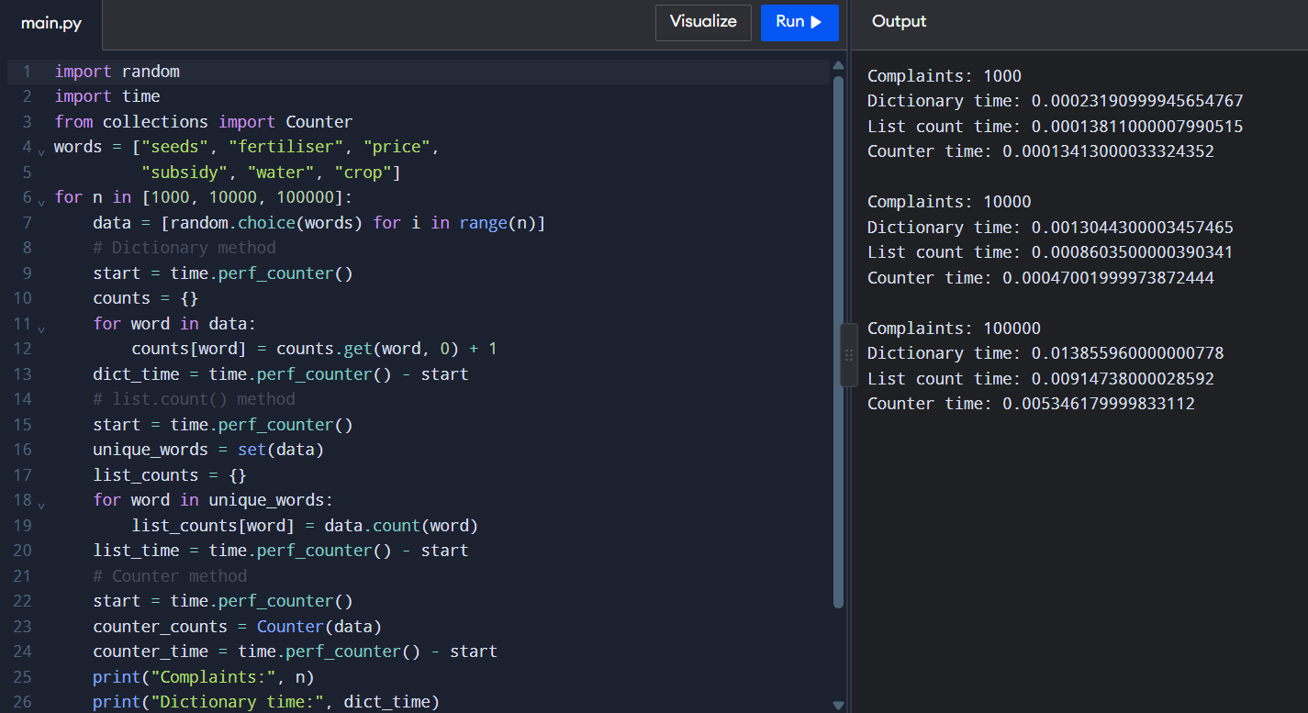

8. Engineering Decision
For analysing 100,000 complaints per day, I would choose the dictionary method or collections.Counter.
They provide efficient word counting with average O(n) time complexity. They are suitable for handling large complaint datasets.
9. Alternative Concept and Complexity Analysis
An alternative method is to use list.count() for counting each distinct word.
This method checks the entire list for every distinct word, requiring O(n × d) time.
Using collections.Counter provides a simpler way to count word frequencies with average O(n) time.
A dictionary is preferred because it provides efficient lookup and allows complaints to be grouped using lists.
10. Conclusion
The program demonstrates the use of Python dictionaries to analyse farmer complaints. It counts frequently used words, groups complaints by district and crop, and identifies the most common words. Dictionary operations make the analysis efficient and suitable for large datasets.

Q4 – SETS: ELECTIVE REGISTRATION CLASH DETECTION (7 MARKS)
1. Aim
To develop a Python program using sets to identify students registered in both electives, exactly one elective and neither elective.
2. Problem Statement
Students register for electives offered during the same time slot. The academic office needs to identify students who have registered for both electives, students registered in exactly one elective and students who have not registered for either elective.
3. Python Program
# Student registrations
ai_elective = {
"192311001", "192311004",
"192311007", "192311009"
}
iot_elective = {
"192311002", "192311004",
"192311009", "192311010"
}
all_students = {
f"1923110{i:02d}" for i in range(1, 11)
}
# Find common students
both = ai_elective & iot_elective
# Find students in exactly one elective
exactly_one = ai_elective ^ iot_elective
# Find students in neither elective
neither = all_students - (ai_elective | iot_elective)
# Display sorted results
print("clash :", sorted(both))
print("exactly one:", sorted(exactly_one))
print("neither :", sorted(neither))
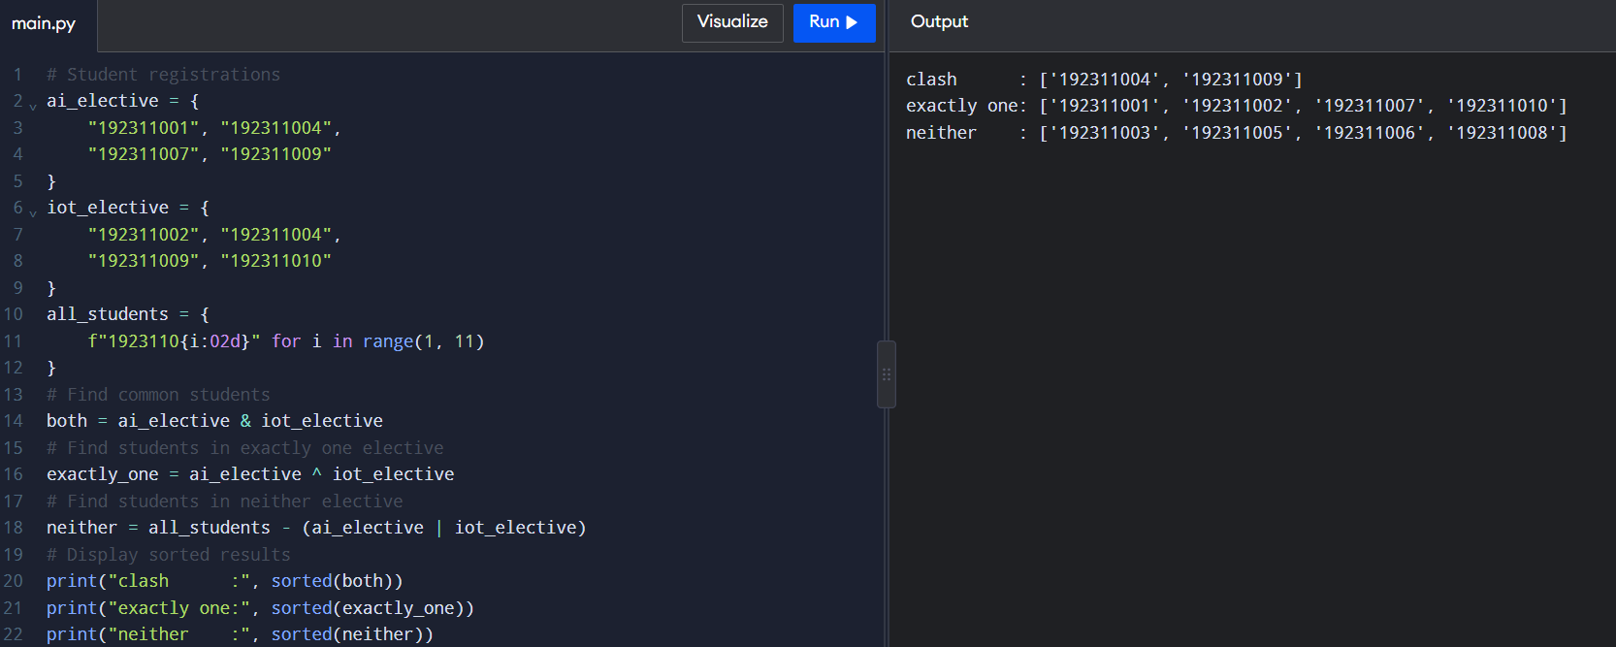
4. Input and Output
Input: Two sets containing student register numbers for AI and IoT electives.
Expected Output:
clash : ['192311004', '192311009']
exactly one: ['192311001', '192311002', '192311007', '192311010']
neither : ['192311003', '192311005', '192311006', '192311008']
5. Analysis of Data
Python sets store unique elements and automatically remove duplicate registrations.
The following set operations are used:
- Union (|): Combines students from both electives.
- Intersection (&): Finds students registered in both electives.
- Difference (-): Finds students present in one set but not the other.
- Symmetric difference (^): Finds students registered in exactly one elective.
Sets provide average O(1) membership testing, which is generally faster than checking membership in a list.
Sets cannot contain lists because lists are mutable. However, they can contain tuples whose elements are hashable.
6. Venn Diagram Explanation
- Intersection represents students registered in both electives.
- Symmetric difference represents students registered in exactly one elective.
- The area outside both sets represents students registered in neither elective.
7. Time and Space Complexity
Operation | Average Time Complexity
Membership testing in a set | O(1)
Union | O(n + m)
Intersection | O(min(n, m)) average
Difference | O(n)
Symmetric difference | O(n + m)
Here, n and m represent the number of students in the two elective sets.
The sets require O(n + m) space for storing registrations.
8. Experimental Investigation
The following program compares membership testing in a list and a set and compares nested loops with set intersection.
import time
for n in [10000, 100000, 1000000]:
students = [str(i) for i in range(n)]
student_set = set(students)
target = str(n - 1)
# List membership
start = time.perf_counter()
result1 = target in students
list_time = time.perf_counter() - start
# Set membership
start = time.perf_counter()
result2 = target in student_set
set_time = time.perf_counter() - start
print("Number of students:", n)
print("List membership time:", list_time)
print("Set membership time:", set_time)
# Compare common students
first = students[:n//2]
second = students[n//4:]
start = time.perf_counter()
common1 = []
for x in first:
for y in second:
if x == y:
common1.append(x)
nested_time = time.perf_counter() - start
start = time.perf_counter()
common2 = set(first) & set(second)
set_time = time.perf_counter() - start
print("Nested loop time:", nested_time)
print("Set intersection time:", set_time)
print()
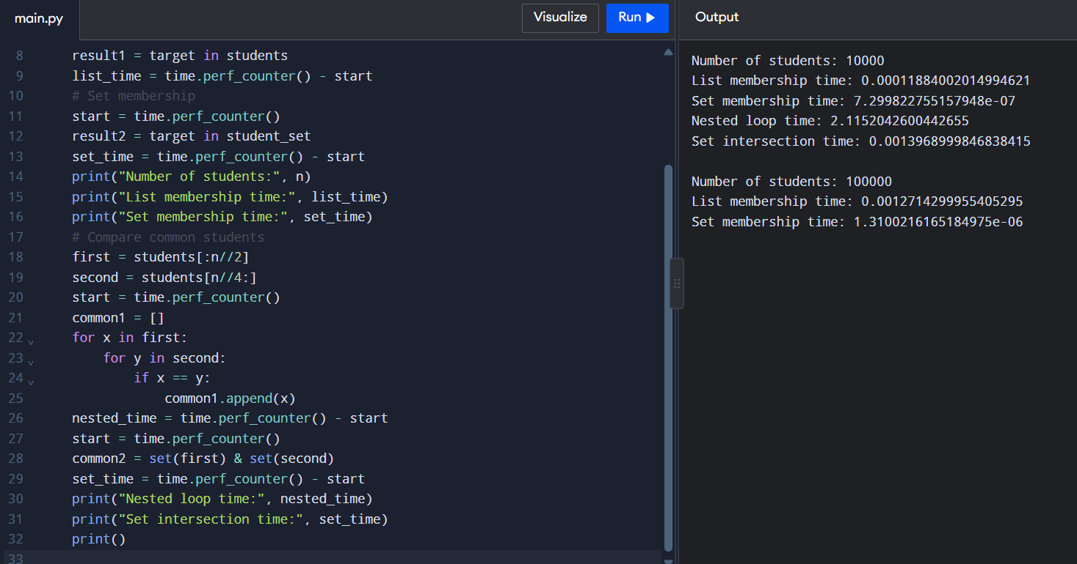
Additional tests:
- Empty electives: All students are in neither elective.
- Identical electives: All registered students are in both electives.
- Small case: Verify the common, exactly-one and neither results manually.
9. Conclusion
The program demonstrates how Python sets can identify elective registration clashes efficiently. Set operations remove duplicates automatically and make membership testing faster. Therefore, sets are suitable for managing student elective registrations.

Q5 – List Comprehension: Cleaning Sensor Readings
1. Aim
To clean sensor readings by removing invalid values, convert valid temperatures from Celsius to Fahrenheit, and identify readings outside the safe temperature range using loops, list comprehension, and map() and filter().
2. Problem Statement
A cold-storage temperature monitor records vaccine storage temperatures every minute. Readings above 50°C or below -50°C are considered sensor errors. The program must remove invalid readings, convert valid temperatures into Fahrenheit, and identify the minutes when the temperature is outside the safe range of 2°C to 8°C.
3. Program
Python Code
readings = [4, 5, 60, 7, -55, 3, 9, 6, 52, 2]
# Method 1: Using for loop
valid1 = []
for temp in readings:
if -50 <= temp <= 50:
valid1.append(temp)
# Method 2: Using list comprehension
valid2 = [temp for temp in readings if -50 <= temp <= 50]
# Method 3: Using filter()
valid3 = list(filter(lambda x: -50 <= x <= 50, readings))
# Convert Celsius to Fahrenheit
fahrenheit = list(map(lambda c: round((c * 9/5) + 32, 2), valid2))
# Find minutes outside the safe temperature range
alarm_minutes = [
i + 1 for i, temp in enumerate(readings)
if -50 <= temp <= 50 and not (2 <= temp <= 8)
]
print("Valid readings:", valid2)
print("Fahrenheit readings:", fahrenheit)
print("Alarm minutes:", alarm_minutes)
print("All methods give same result:", valid1 == valid2 == valid3)
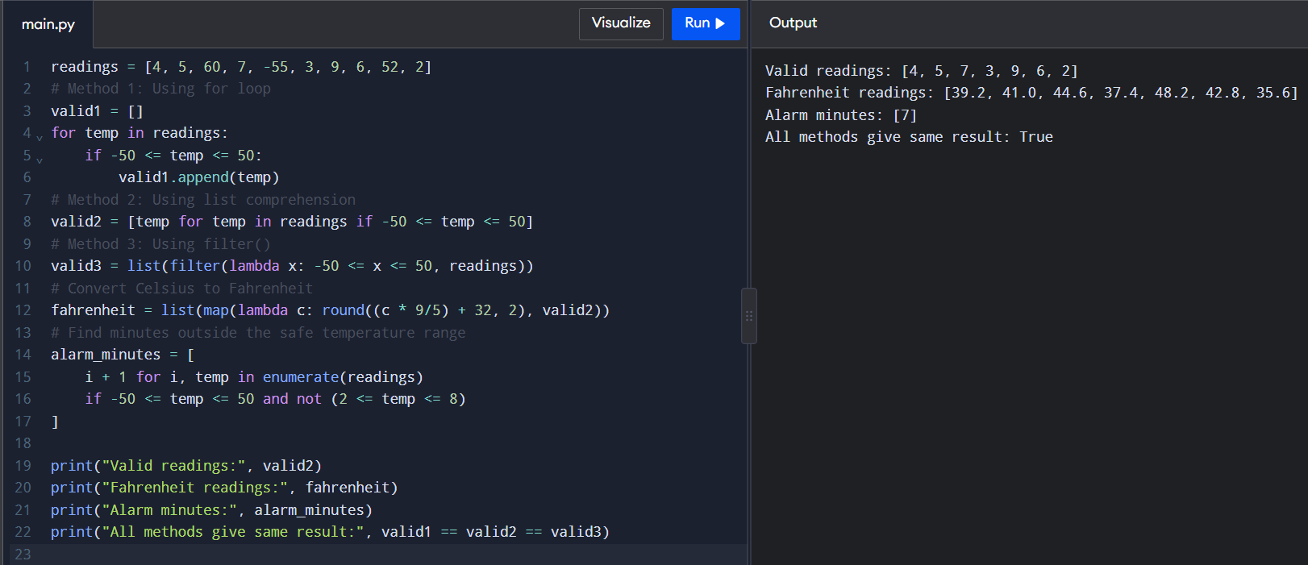
4. Input
The temperature readings are:
[4, 5, 60, 7, -55, 3, 9, 6, 52, 2]
5. Output
Valid readings: [4, 5, 7, 3, 9, 6, 2]
Fahrenheit readings: [39.2, 41.0, 44.6, 37.4, 48.2, 42.8, 35.6]
Alarm minutes: [7]
All methods give same result: True
6. Analysis
- List comprehension: Creates a new list using a single expression and an optional condition.
- Dictionary comprehension: Creates a dictionary using a compact expression.
- Set comprehension: Creates a set and automatically removes duplicate values.
- Generator expression: Produces values one at a time without storing the complete result in memory.
- A normal loop is easier to understand when the processing logic is complex, while list comprehension is suitable for simple filtering and conversion.
7. Experimental Code
The following program compares the execution time of a for loop, list comprehension, and filter() for different input sizes.
import time
import random
import sys
for n in [10000, 100000, 1000000]:
readings = [random.randint(-60, 60) for _ in range(n)]
start = time.perf_counter()
a = []
for x in readings:
if -50 <= x <= 50:
a.append(x)
loop_time = time.perf_counter() - start
start = time.perf_counter()
b = [x for x in readings if -50 <= x <= 50]
comp_time = time.perf_counter() - start
start = time.perf_counter()
c = list(filter(lambda x: -50 <= x <= 50, readings))
filter_time = time.perf_counter() - start
print("\nReadings:", n)
print("For loop time:", loop_time)
print("List comprehension time:", comp_time)
print("Filter time:", filter_time)
print("Same result:", a == b == c)
# Compare memory usage
valid_list = [x for x in readings if -50 <= x <= 50]
valid_generator = (x for x in readings if -50 <= x <= 50)
print("\nList memory:", sys.getsizeof(valid_list))
print("Generator memory:", sys.getsizeof(valid_generator))
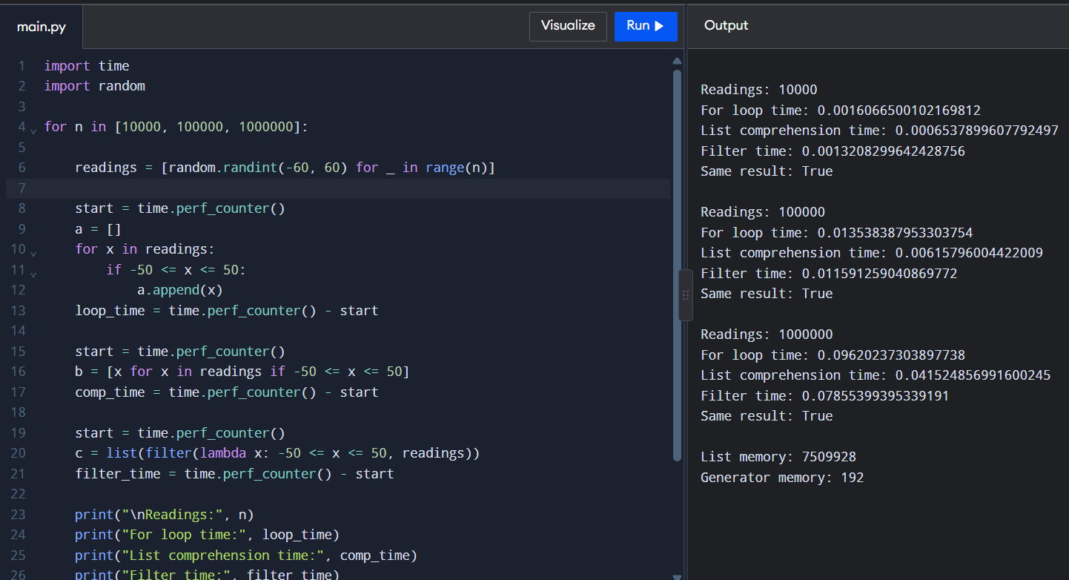
8. Complexity Analysis
Operation | Time Complexity
Cleaning readings | O(n)
Fahrenheit conversion | O(n)
Finding alarm minutes | O(n)
List comprehension space | O(n)
Generator expression extra space | O(1)
Here, n represents the number of temperature readings.
9. Alternative Approach
A generator expression can process valid readings without storing all the values in a list.
readings = [4, 5, 60, 7, -55, 3, 9, 6]

total = sum(x for x in readings if -50 <= x <= 50)
print("Total of valid readings:", total)
Both list comprehension and generator expressions take O(n) time. However, a generator uses less extra memory because it produces values one at a time.
10. Conclusion
List comprehension provides a simple and readable way to clean and convert sensor readings. The experiment compares the execution time of different methods. List comprehension is suitable for simple operations, while generator expressions are useful when memory usage is important.

Q6 – Nested Data: A Railway Timetable
1. Aim
To create a railway timetable using nested dictionaries, lists, tuples, and sets. The program finds trains stopping at a given station on a particular day and sorts them according to departure time.
2. Problem Statement
A railway enquiry counter needs to maintain train details, including train number, train name, station names, arrival time, departure time, and running days. The program should find trains stopping at a selected station on a selected day and display them in departure-time order.
3. Program
Python Code
trains = {
"12601": {
"name": "Chennai Express",
"stations": [
("Chennai Central", "06:00", "06:10"),
("Katpadi", "08:00", "08:05"),
("Bangalore", "11:00", "11:10")
],
"days": {"Monday", "Wednesday", "Friday"}
},
"12602": {
"name": "Coimbatore Express",
"stations": [
("Chennai Central", "07:00", "07:15"),
("Salem", "10:00", "10:05"),
("Coimbatore", "12:00", "12:10")
],
"days": {"Monday", "Tuesday", "Thursday"}
},
"12603": {
"name": "Pandian Express",
"stations": [
("Madurai", "05:00", "05:10"),
("Chennai Central", "09:00", "09:15"),
("Villupuram", "11:00", "11:05")
],
"days": {"Tuesday", "Thursday", "Saturday"}
},
"12604": {
"name": "Vaigai Express",
"stations": [
("Chennai Central", "05:30", "05:40"),
("Villupuram", "07:30", "07:35"),
("Madurai", "11:00", "11:10")
],
"days": {"Monday", "Wednesday", "Friday"}
},
"12605": {
"name": "Kovai Express",
"stations": [
("Chennai Central", "08:00", "08:10"),
("Salem", "11:00", "11:05"),
("Coimbatore", "13:00", "13:10")
],
"days": {"Monday", "Friday", "Sunday"}
}
}
station_name = "Chennai Central"
selected_day = "Monday"
result = []
for number, details in trains.items():
if selected_day in details["days"]:
for station, arrival, departure in details["stations"]:
if station == station_name:
result.append(
(number, details["name"], arrival, departure)
)
result.sort(key=lambda x: x[3])
print("Trains stopping at", station_name, "on", selected_day)
for train in result:
print("Train Number:", train[0])
print("Train Name:", train[1])
print("Arrival:", train[2])
print("Departure:", train[3])
print()
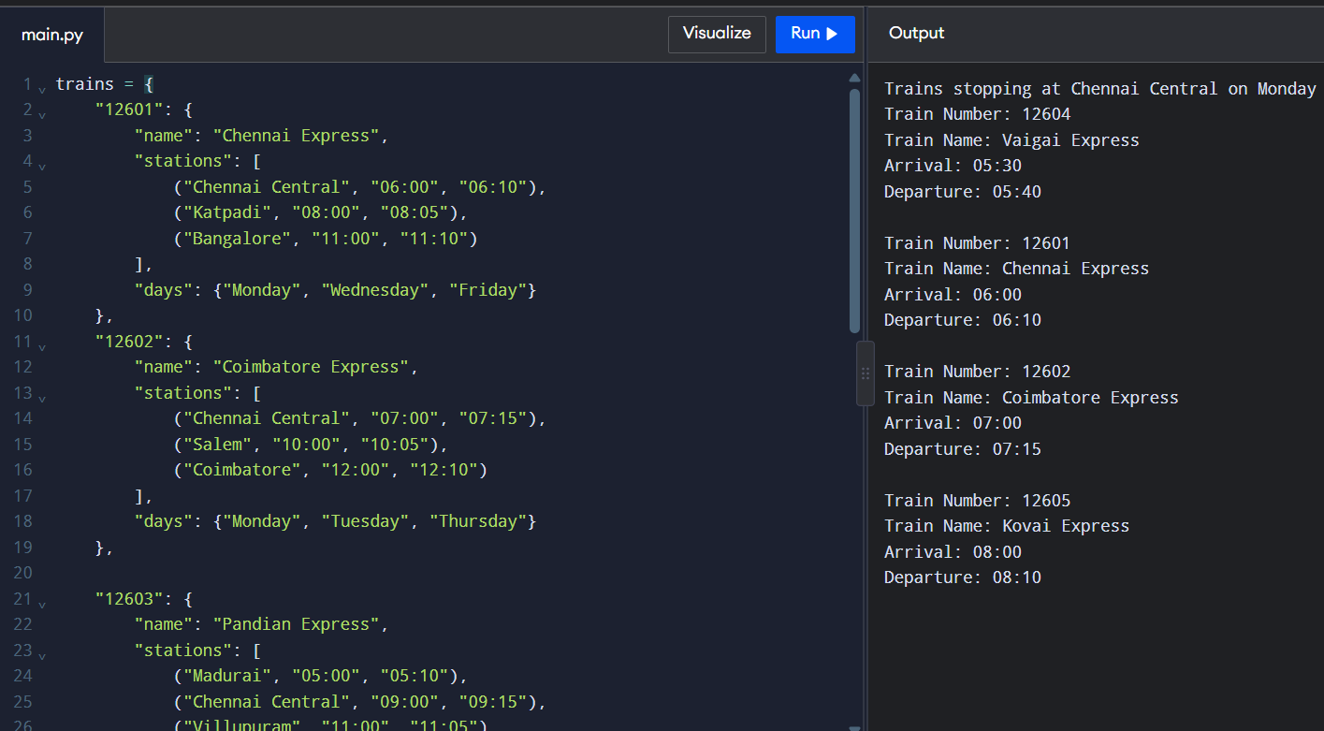
4. Input
- Station name: Chennai Central
- Selected day: Monday
5. Output
Trains stopping at Chennai Central on Monday

Train Number: 12604
Train Name: Vaigai Express
Arrival: 05:30
Departure: 05:40
Train Number: 12601
Train Name: Chennai Express
Arrival: 06:00
Departure: 06:10
Train Number: 12602
Train Name: Coimbatore Express
Arrival: 07:00
Departure: 07:15
Train Number: 12605
Train Name: Kovai Express
Arrival: 08:00
Departure: 08:10
6. Analysis
The program uses different Python data structures:
- Dictionary: Stores train details using the train number as the key.
- List: Stores the stations visited by each train.
- Tuple: Stores station name, arrival time, and departure time.
- Set: Stores the days on which each train operates.
The departure time of the third station of train 12601 can be accessed using:
trains["12601"]["stations"][2][2]
Dictionary lookup takes O(1) average time. However, finding trains at a station requires checking the station lists.
7. Experimental Code
The following program compares searching trains by scanning the timetable with searching through a station index.
import time
timetable = {}
for i in range(1000):
timetable[str(i)] = {
"stations": [
("Chennai Central", "06:00", "06:10"),
("Salem", "09:00", "09:10")
]
}
# Search without an index
start = time.perf_counter()
for number, details in timetable.items():
for station, arrival, departure in details["stations"]:
if station == "Chennai Central":
pass
normal_time = time.perf_counter() - start
# Create station index
station_index = {}
for number, details in timetable.items():
for station, arrival, departure in details["stations"]:
station_index.setdefault(station, []).append(number)
# Search using the index
start = time.perf_counter()

result = station_index.get("Chennai Central", [])
index_time = time.perf_counter() - start
print("Search without index:", normal_time)
print("Search with index:", index_time)
print("Trains found:", len(result))
The experiment can be repeated with 100, 1,000, and 10,000 trains to compare the search times.
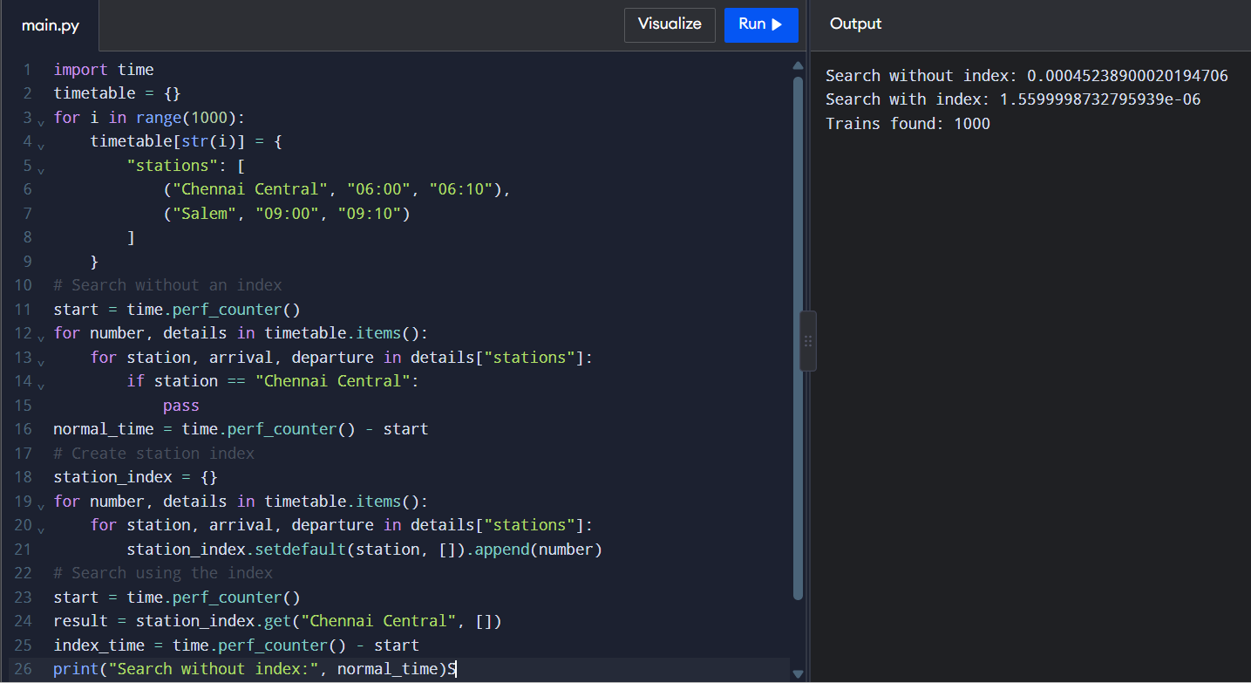
8. Complexity Analysis
Operation | Time Complexity
Accessing a train by number | O(1) average
Searching without an index | O(T × S)
Sorting matching trains | O(R log R)
Searching using station index | O(1 + R) to retrieve the matching list
Here, T represents the number of trains, S the average number of stations per train, and R the number of trains stopping at the selected station.
9. Alternative Approach
A flat list can store each train and station as a separate record containing train number, station name, arrival time, departure time, and running days.
This approach requires scanning the records to find matching trains. A station index provides faster searching but requires additional memory.
10. Conclusion
Nested data structures are useful for storing railway timetable information. Dictionaries provide quick access to train details, while lists, tuples, and sets organize station and running-day information. A station index improves searching speed, but it requires additional memory.

Q7 – Design a Contact-Merging Program from First Principles
1. Aim
To develop a Python program that combines contacts from multiple devices, identifies duplicate contacts, and stores each person's phone numbers and email addresses without unnecessary duplication.
2. Problem Statement
Contacts stored in two mobile phones and a SIM card may contain duplicate entries. The same person's name and phone number may be saved in different formats. The program must identify duplicate contacts, merge their details, and display each person only once with all available phone numbers and email addresses.
3. Requirements
The program should:
- Accept contacts from multiple sources.
- Normalize names, phone numbers, and email addresses.
- Identify duplicate contacts using normalized phone numbers.
- Combine phone numbers and email addresses.
- Avoid duplicate entries.
- Display the final merged contact list.
4. Data Structures Used
- Dictionary: Stores contacts using a normalized phone number as the key.
- Set: Stores unique phone numbers and email addresses.
- List: Stores the original contact records.
5. Program
Python Code
contacts = [
{"name": "Arun Kumar", "phone": "98765 43210",
"email": "arun@gmail.com"},

{"name": "Arun Kumar", "phone": "+91-9876543210",
"email": "ARUN@gmail.com"},
{"name": "Priya", "phone": "91234 56789",
"email": "priya@gmail.com"},
{"name": "Priya", "phone": "9123456789",
"email": "priya@yahoo.com"},
{"name": "Ravi", "phone": "99887 76655",
"email": "ravi@gmail.com"}
]
merged = {}
for contact in contacts:
name = contact["name"].strip().title()
phone = "".join(
ch for ch in contact["phone"] if ch.isdigit()
)
if len(phone) > 10:
phone = phone[-10:]
email = contact["email"].strip().lower()
if phone in merged:
merged[phone]["phones"].add(phone)
merged[phone]["emails"].add(email)
else:
merged[phone] = {
"name": name,
"phones": {phone},
"emails": {email}
}
print("Merged Contact List")
for contact in merged.values():
print("Name:", contact["name"])
print("Phone Numbers:", sorted(contact["phones"]))
print("Email Addresses:", sorted(contact["emails"]))
print()
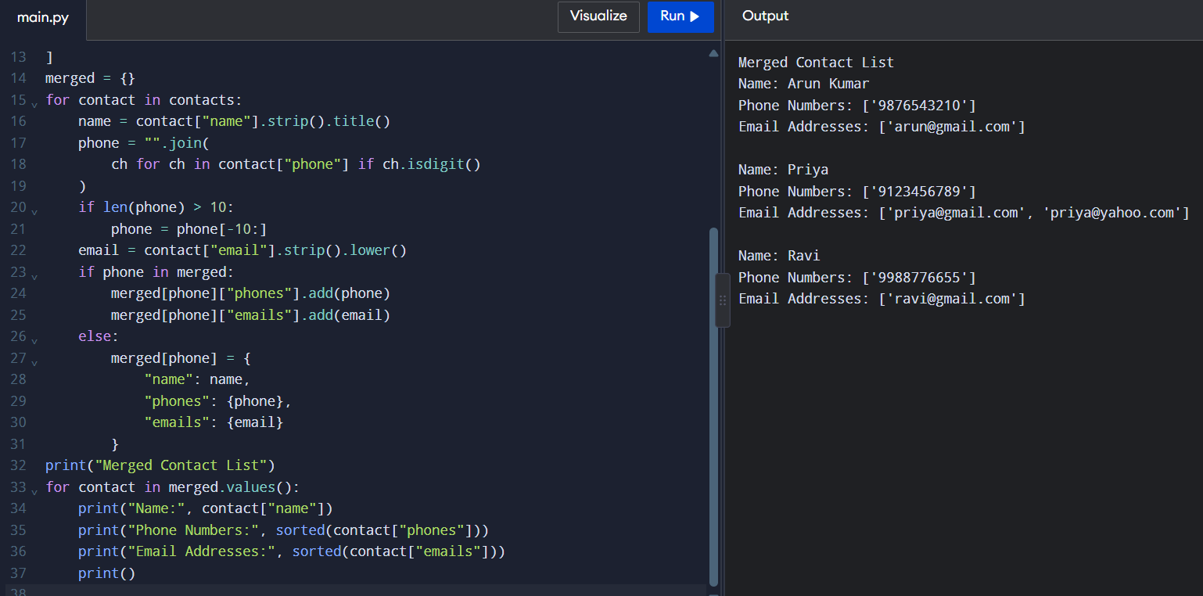
6. Input
The program contains five contact records from different sources. Some contacts have duplicate phone numbers saved in different formats.
7. Output
Merged Contact List
Name: Arun Kumar
Phone Numbers: ['9876543210']
Email Addresses: ['arun@gmail.com']
Name: Priya
Phone Numbers: ['9123456789']
Email Addresses: ['priya@gmail.com', 'priya@yahoo.com']
Name: Ravi
Phone Numbers: ['9988776655']
Email Addresses: ['ravi@gmail.com']
8. Analysis
The program first removes spaces and special characters from phone numbers. It also converts email addresses into lowercase to make comparison easier.
A dictionary is used to identify duplicate contacts quickly. When a matching phone number is found, the program adds the contact's email address to the existing record using a set. Sets automatically prevent duplicate values.
A dictionary provides average O(1) lookup time, making it more efficient than comparing every contact with every other contact.
9. Experimental Code
The following program compares the time required by a pairwise comparison method and a dictionary-based method.
import time
for n in [1000, 10000, 100000]:
contacts = [
"98765" + str(i).zfill(5)
for i in range(n)
]
# Pairwise comparison
start = time.perf_counter()
duplicates = []
for i in range(len(contacts)):
for j in range(i + 1, len(contacts)):
if contacts[i] == contacts[j]:
duplicates.append(contacts[i])
pair_time = time.perf_counter() - start
# Dictionary-based method
start = time.perf_counter()
unique = {}
for phone in contacts:
unique[phone] = phone
dict_time = time.perf_counter() - start
print("\nContacts:", n)
print("Pairwise time:", pair_time)
print("Dictionary time:", dict_time)
print("Unique contacts:", len(unique))
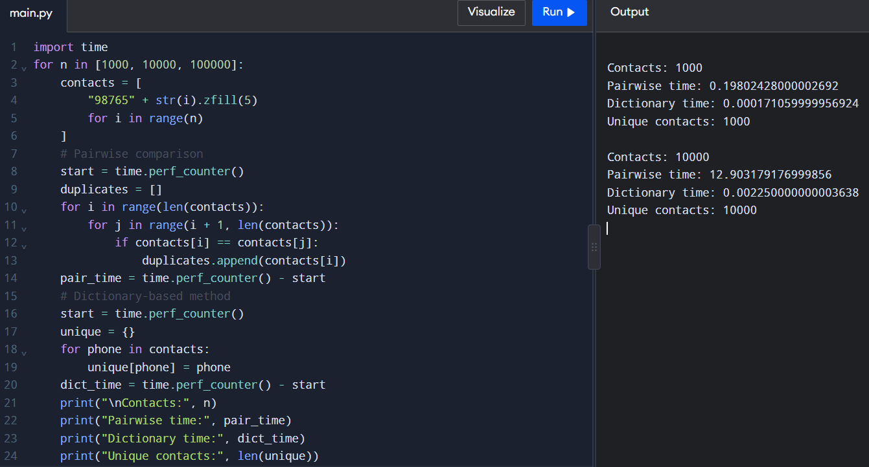
10. Complexity Analysis
Operation | Time Complexity
Normalizing phone numbers | O(L) per contact
Dictionary lookup | O(1) average
Merging all contacts | O(n) average, excluding normalization
Pairwise comparison | O(n²)
Storing merged contacts | O(n) space
Here, n represents the number of contacts and L represents the length of a phone number.
11. Alternative Approach
Another approach is to compare every contact with every other contact to identify duplicates.
This method takes O(n²) time because each contact must be compared with the remaining contacts. A dictionary-based approach is more efficient, taking O(n) average time for processing all contacts.
However, if two people have the same name, they should not automatically be treated as the same person. Phone numbers or other reliable details should be used for identification.
12. Conclusion
The contact-merging program uses dictionaries and sets to identify and combine duplicate contacts. Phone number normalization helps identify contacts saved in different formats. The dictionary-based approach is faster than pairwise comparison for large contact lists. However, contacts without a reliable shared identifier may require manual verification.

